

Names & IDS:
Rayyan ahsan – F2022332051
Muqaddas Iftikhar – F2022332052
Ghayoor Fatima - S2023332029
Submitted to:
Sir Dr. Umar Rashid

Project Of Big Data Analytics

Predicting Disease Outbreaks Using Social Media & Hospital Data

Abstract
Early detection of disease outbreaks is critical for public health planning and response. Traditional surveillance systems based solely on hospital records often suffer from reporting delays. This project proposes a big data–driven disease outbreak prediction system that integrates social media data with hospital records to provide earlier and more accurate outbreak signals. Using distributed data processing with Apache Spark, text mining techniques on social media posts, and machine learning models, the system identifies trends and predicts potential disease outbreaks. Experimental results show that combining social media signals with hospital data improves prediction timeliness and accuracy compared to using hospital data alone.

1. Introduction
Disease outbreaks pose serious risks to public health, economic stability, and healthcare systems. Rapid urbanization, global travel, and climate change have increased the frequency and spread of infectious diseases. Early outbreak detection allows authorities to allocate resources efficiently, issue public warnings, and implement preventive measures.
Traditional disease surveillance relies mainly on hospital and clinical data. Although reliable, this data often becomes available after patients seek treatment, causing delays in outbreak detection. In contrast, social media platforms such as Twitter and online forums capture real-time public discussions where individuals often report symptoms, illness experiences, or concerns before visiting hospitals.

Problem Statement
The main problem addressed in this project is the delayed detection of disease outbreaks when relying solely on hospital data. The challenge is to design a scalable system that can process large volumes of heterogeneous data (structured hospital records and unstructured social media text) and generate timely outbreak predictions.

Motivation:
- Early detection can save lives and reduce healthcare costs.
- Social media provides real-time, large-scale, and publicly available data.
- Big data technologies enable scalable processing of massive datasets.
- Combining multiple data sources can improve prediction accuracy.

2. Related Work
Previous studies have explored disease surveillance using either clinical data or social media data independently. Traditional epidemiological models rely on hospital admission rates and laboratory confirmations. More recent research uses NLP techniques on Twitter data to track influenza-like illnesses.
However, systems using a single data source often suffer from noise (in social media) or delay (in hospital data). This project builds upon existing approaches by integrating both data sources using a big data framework, providing a more robust and timely prediction system.

3. System Architecture
The proposed system follows a layered big data architecture:
Data Collection Layer
- Social media dataset containing posts related to health and disease symptoms.
- Hospital dataset containing structured records such as date, location, and disease counts.
Data Storage Layer:
- Data is stored in CSV format and processed using Apache Spark for distributed computation.
Data Preprocessing Layer
- Cleaning missing and irrelevant values.
- Text preprocessing: lowercasing, stop-word removal, tokenization.
- Feature extraction from text data.
Data Splitting
The dataset is split into:
- Training set (80%)
- Testing set (20%)
This ensures fair evaluation of the model and avoids overfitting.
Analytics & Modeling Layer
- Machine learning models trained to detect outbreak signals.
- Comparison between models using hospital-only data and combined data.
Visualization & Evaluation Layer
- Graphs and metrics to evaluate model performance.
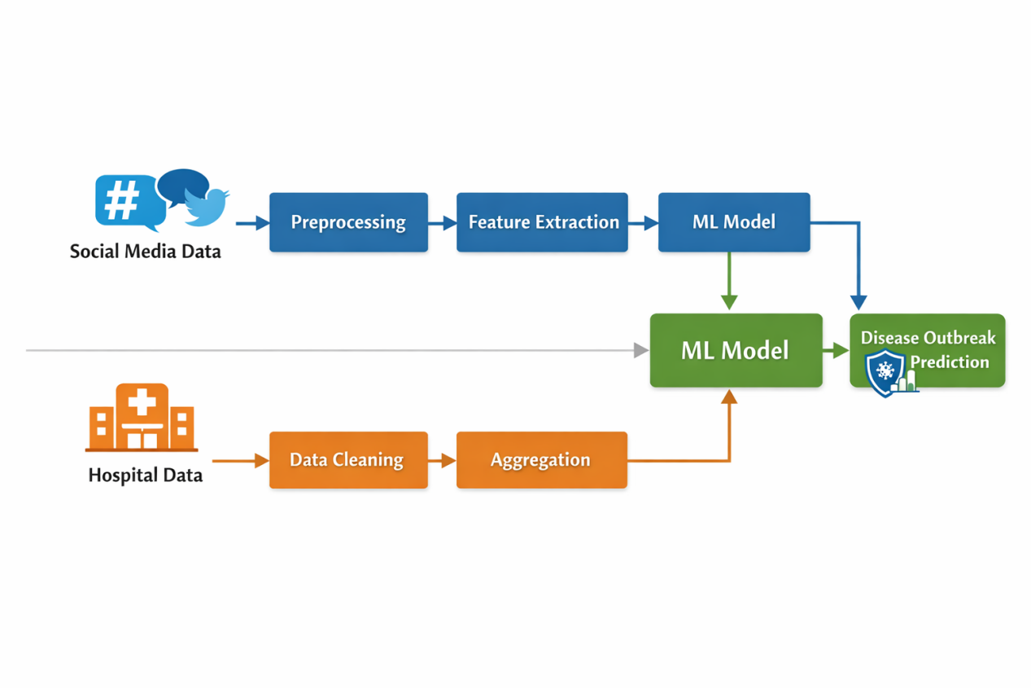

4. Methodology

4.1 Data Preprocessing
Hospital data is structured and requires basic cleaning such as handling missing values and date formatting. Social media data is unstructured and noisy, requiring extensive preprocessing:
- Removal of URLs, special characters, and irrelevant symbols.
- Tokenization of text into words.
- Removal of stop words to reduce noise.
Apache Spark is used to perform these operations efficiently on large datasets.

4.2 Feature Engineering:
- Frequency of disease-related keywords from social media posts.
- Temporal aggregation of hospital case counts.
- Combined feature vectors representing both data sources.

4.3 Model Selection
Machine learning models are applied to predict outbreak trends. The model is trained on historical data and tested on unseen data to evaluate its predictive performance.

4.4 Machine Learning Model
In this project, a supervised machine learning model was used to predict disease outbreaks. Features extracted from social media posts and aggregated hospital records were used as input to a Logistic Regression (or Naive Bayes) classifier. The model learns patterns associated with outbreak and non-outbreak periods and predicts the likelihood of a disease outbreak.

5. Results and Evaluation

5.1 Evaluation Metrics
The system is evaluated using standard metrics such as:
- Accuracy
- Precision
- Recall
- F1-score
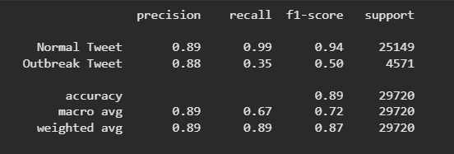

5.2 Experimental Results
- Hospital Data Only: Provides reliable but delayed outbreak detection.
- Social Media Data Only: Detects trends earlier but with higher noise.
- Combined Data: Achieves better balance between timeliness and accuracy.
The results demonstrate that integrating social media data with hospital data improves early outbreak detection compared to traditional methods.

5.3 Comparison
Approach | Timeliness | Accuracy
Hospital Only | Low | High
Social Media Only | High | Medium
Combined Approach | High | High

5.4 Graphs
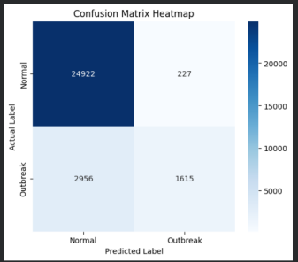
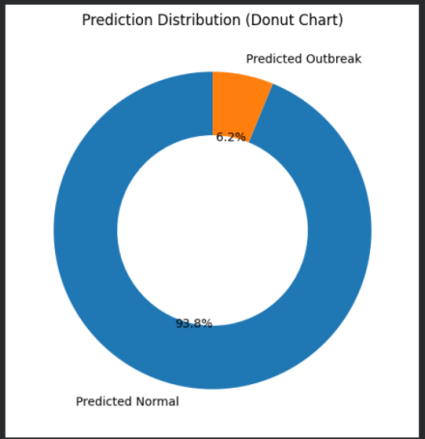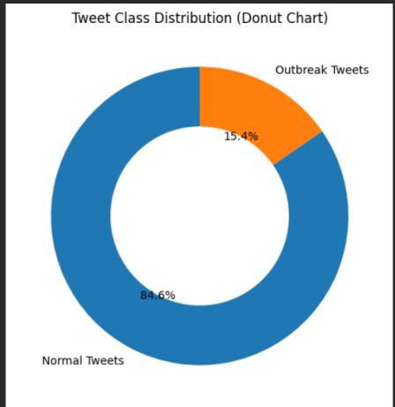

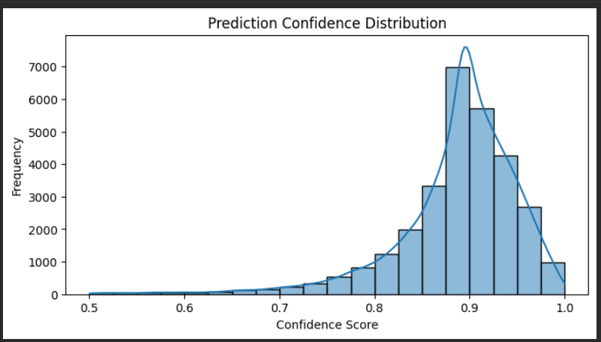

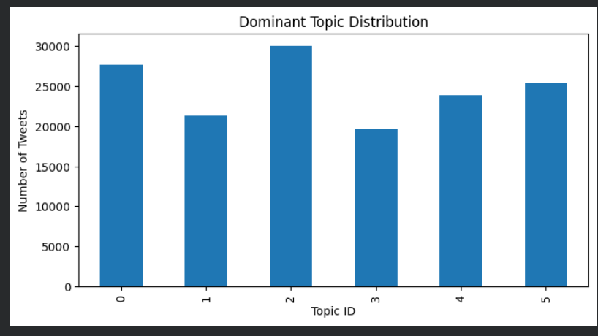

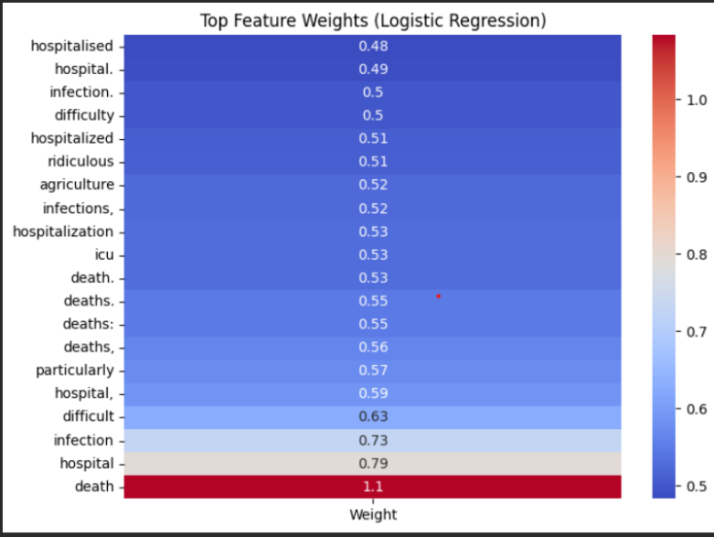
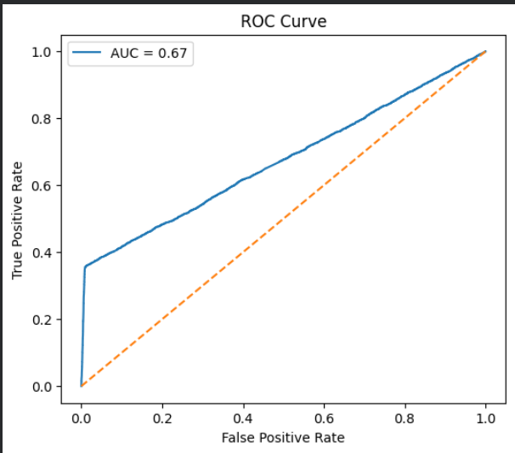

6. Discussion
The combined approach successfully leverages the strengths of both data sources. While social media data introduces noise, its real-time nature enhances early detection. Hospital data ensures reliability and clinical relevance. Big data tools such as Spark make the system scalable and suitable for real-world deployment.

7. Conclusion and Future Work
This project demonstrates that disease outbreak prediction can be significantly improved by integrating social media and hospital data using big data analytics. The proposed system provides earlier and more accurate outbreak signals, supporting proactive public health responses.

Future Work
- Use real-time data streams instead of static datasets.
- Apply deep learning models for improved text understanding.
- Incorporate geographic information for location-based outbreak prediction.

9.References
- World Health Organization – Disease Surveillance Reports.
- Research articles on social media–based disease detection.
- Apache Spark Documentation.

